Title (Times New Roman, font size 18)

Presenting Author¹, Co-Authors^{2,*} (Times New
Roman, font size 12)
Department, Institution, Address, City, Country (Italic, Times New Roman, font size 11)
*Corresponding Author E-mail: (Times New Roman, font size 10)
You are invited to submit your abstract (Maximum one A4 page). The topics of the Conference includes, Physics of laser ablation and laser-induced plasma, Diagnostics and spectroscopy of laser-induced plasma, Novel LIBS instrumentation and technologies, Chemometrics, machine Learning, and AI for LIBS, Qualitative and quantitative analytical methods, Microanalysis and mapping, Applications of LIBS (industrial, energy, environmental, biological, geological, cultural heritage...), LIBS in extreme conditions (space, ocean, nuclear...), Comparison and hyphenation with other techniques (XRF, ICP-OES/MS, LIF, Raman...), Novel laser sources, spectrometers, and detectors, Others… For online technical program consistency, this Abstract Template must be used for abstract submission. Times New Roman, font size 11 for the text of abstract.

Abstracts of a maximum one A4 page, including any illustration, must be submitted online before May 10, 2026. Authors will be notified of abstract acceptance by June 20, 2026. For every paper accepted for oral or poster presentation, at least one author must complete the registration by October 30, 2026.

Keywords: Keyword1; Keyword2; Keyword3; Keyword4; (Maximum 4). (Times New Roman, font size 11)

References must follow the following format^{[1]}.

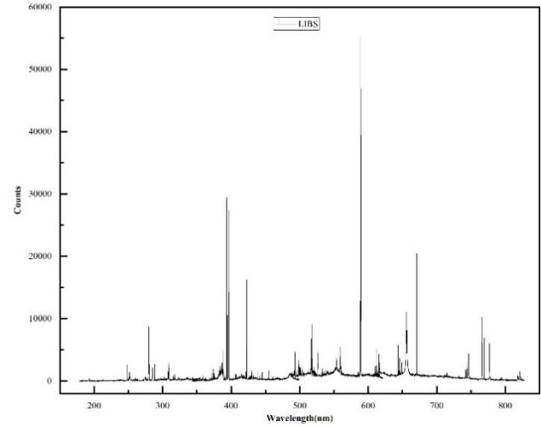
Fig. 1 An illustration is always encouraged (legend: Times New Roman, font size 10, centered)

REFERENCES
[1] Yao S, Yu Z, Hou Z, et al. Development of Laser-Induced Breakdown Spectroscopy Based Spectral Tandem Technology: A Topical Review[J]. TrAC Trends in Analytical Chemistry, 2024, 177: 117795.

